Requirements and Design



Introduction

For our project we have decided to use a casino as a model for our burglar alarm system. We have decided to call it ‘Casino 404’. Given the equipment given we will design an appropriate burglar alarm system for our casino as well as considering all stakeholder, user and system requirements.

As of October 2025, there are just under 3,000 casinos in the UK¹. These buildings require a very high level of security due to the large amounts of cash and chips that they store, which are seen as valuable to burglars. A loss of these valuables can severely affect the casino’s revenue, leading to drastic economic impacts such as building closures. A break-in also affects the safety of the casino’s staff, its customers and locals in the surrounding area.

Therefore, casino companies need to install reliable, secure alarm systems to reduce the chances of a break-in. This is why we have decided to model our system around a casino. Since casinos are public buildings, more stakeholders will be required to consider compared to a standard household building, we will also have to consider more accessibility requirements for our system.

System Design / Layout

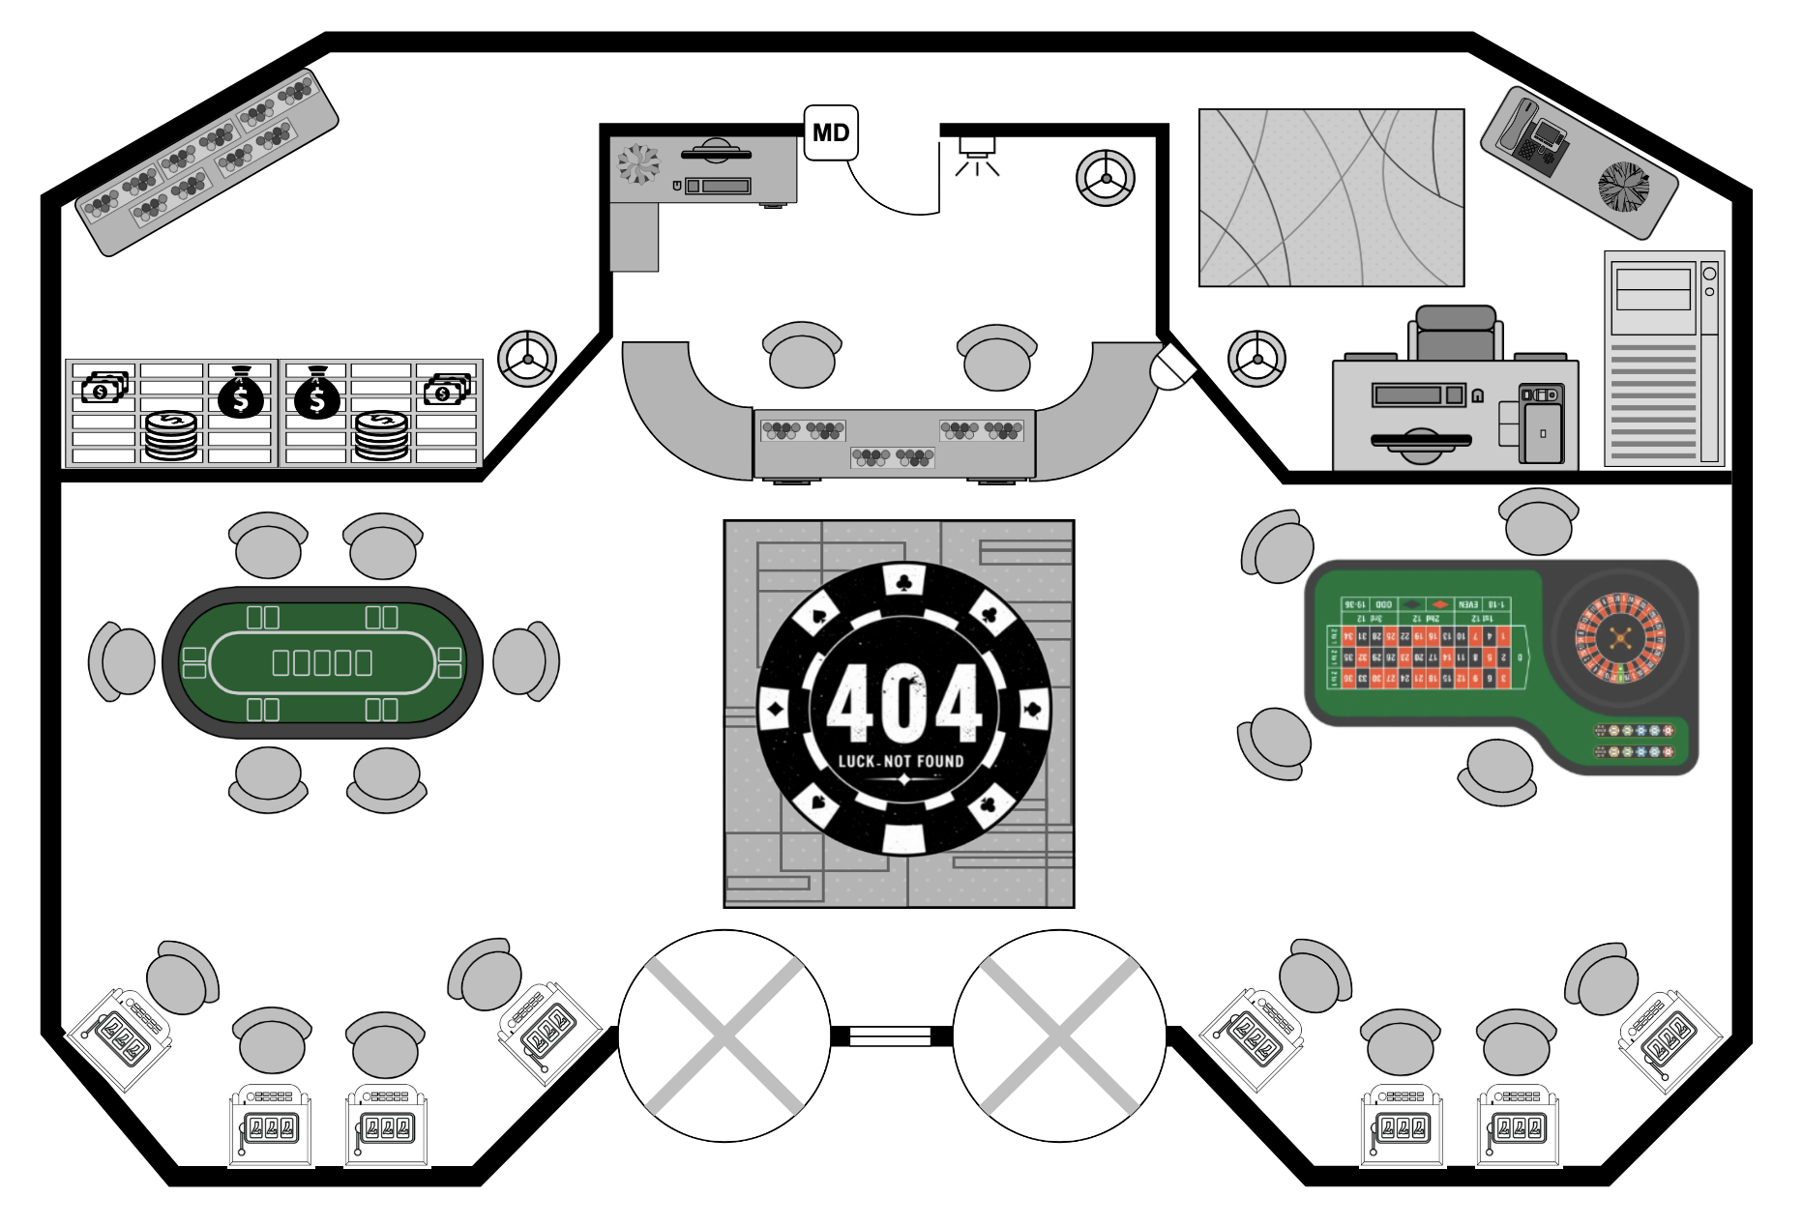
- Motion sensor
- Burglar alarm
- Panic button

Our design installs the listed motion sensor and alarm (buzzer) at the entrance to the staff-only area of the casino. This will be disabled during working hours as staff will be sat behind the main desk, however casinos tend to close in the mornings. For our design we will have the alarm armed between 5am and 12pm.

The first staff to enter work before 12pm can therefore use face scan on the monitor or enter the pin at the desk outside the staffroom (next to the motion sensor door). Our alarm is placed on the wall next to this door (less wiring required), facing towards the main room of the casino. If we were given more equipment (more scalability) we would have motion sensors on the main entrance doors as well as alarms outside the building and also alarms inside the staff room. Our building has a window (between the 2 revolving doors) as required.

The monitor (same desktop used to disarm the alarm system) will inform the user of the status of the sensors and actuators when powered. We considered having the motion sensor on the main revolving doors (will lock in closing hours), however with a simple system this would mean the alarm would go off every time staff enter (until system is disarmed). Our system still protects the valuable part of the building (money/chip bank / staffroom servers) and allows staff to disarm said system before entering this room from the outside. The system also has a panic button which both the customers and staff can access in case of an emergency break-in.

Stakeholder Analysis

Stakeholder | How they will use the system | Potential restrictions
- Building users (e.g. staff and customers) | The burglar alarm system will notify them of any break-in within their property, providing a layer of security. | Blind - May not be able to see the numbers on the keypad  Deaf - May not be able to hear the alarm  Disability - wheelchair users may not be able to reach the keypad if it is too high
- Insurance company | They will need to pay out any damages that occur as a result of a break-in | They may have their own policies that the system must meet
- Law enforcement | They will need to be aware of any break-in as soon as possible to control the situation | Poor communication with the alarm system may delay their response, which may allow intruders to escape
- Locals | They need be exposed to the loud noise from the alarm as a form of warning | They may not hear the alarm if it is too quiet, therefore they won’t be warned of a break-in
- Maintenance/ installation staff | They will be responsible for ensuring that the alarm system is fully functional | If certain components of the system are difficult to access, maintenance would struggle to fix them if they become faulty.  Confusing configuration of the components will increase the maintenance difficulty of the system
- Intruders | They may try to damage the alarm system in order to prevent the buzzer from sounding | If they have easy access to important wiring, they’ll be able to disarm the system easily.
- Alarm Sales company | They will sell the alarm system to the casino | They may have product quality requirements in line with their regulations in order to boost their own profits, such as having an adaptable system that can be sold to multiple clients

User Requirements

The user requirements listed below describe the services the system must provide to its users/stakeholders are are illustrated by the UML use case diagram:

1 - Casino staff members
1.1 The system should allow authorised staff to arm the alarm (recognise face scan).
1.2 The system should allow authorised staff to disarm the alarm (recognise face scan).
1.3 The system shall allow authorised staff to activate the panic alarm button in emergencies.

2 - Customers
2.1 The system shall clearly indicate alarm activation status to customers.
2.2 The system shall allow customers to activate the panic alarm button in emergencies.

3 - Law enforcement
3.1 Law enforcement shall be notified when alarm is triggered by unauthorised personnel
3.2 Law enforcement shall be provided with relevant incident information

4 - Locals
4.1 The system shall provide a loud and visible alarm signal detectable by nearby individuals.

5 - Maintenance / Installation Staff
5.1 The system shall allow maintenance / installation staff to install more alarm units (scalable system).
5.2 The system shall allow maintenance staff to test and repair alarms.
5.3 The system shall allow maintenance staff to arm the alarm (recognise face scan).
5.4 The system shall allow maintenance staff to disarm the alarm (recognise face scan).

6 - Alarm sales company
6.1 The system shall be registered by the sales company to record the sale of an alarm system.
6.2 The sales company shall record customer details associated with the sale.

Uml use case diagram for the Alarm system:

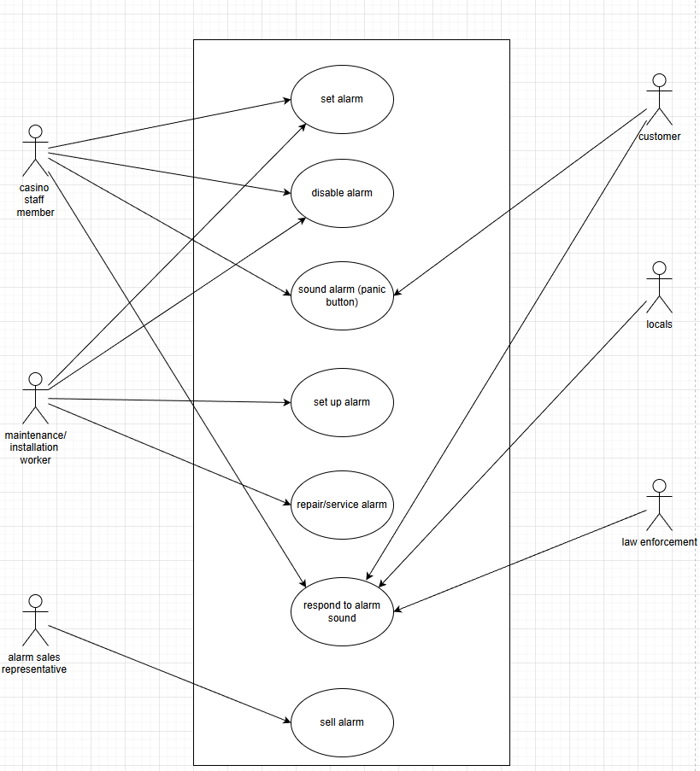

System Requirements Specification

- The system shall allow authorised staff to disarm and arm the alarm using facial recognition
  - The system shall use a built in camera to capture the user’s face when authentication is required to arm or disarm the system. (SA1) (F)
    - The system shall use serial communication to pass any data from Matlab (software) to the Arduino (hardware) in order to process the facial recognition system. (F)
    - The system should be operable from a minimum of 50cm away. (NF)
    - The system should be able to scan different types of faces, as facial hair or scarring may prevent the scanner from working properly. (NF)
  - The system shall compare user captured face scan with a database of user profiles. (F)
  - The system shall allow up to 3 attempted facial recognition scans. (SA1) (F)
    - After each failed scan the screen shall display the message ‘Face not recognised, try again.’ (F)
    - After 3 consecutive failed attempts, the system shall fall back to a PIN input authentication (as per requirement 2). (F)
  - If the user's face is recognised as an authorised member of staff, the system shall allow the user to disarm or arm the alarm. (SA1) (F)
  - The scanner should only be switched on when it is needed to prevent the scanning of other people walking past accidentally, which could be a violation of privacy. (SA1 and SA2) (NF)

- If the facial recognition system fails, the system shall allow the user to enter a PIN using the computer's keyboard to disarm or arm the alarm:
  - The PIN shall be 4 digits long. (F)
  - The system shall compare the imputed PIN with the stored correct PIN. (F)
  - The system shall allow up to 3 failed PIN attempts. (F)
  - The system shall correctly display a sensible response to incorrect PIN input attempts
    - After each failed attempt the screen shall display the message ‘Incorrect PIN, try again.’ (F)
    - After 3 failed attempts, the authentication system shall close and lock for a period of time before reattempting. (F)
  - If PIN authentication is successful, the system shall allow the user to disarm or arm the alarm. (F)
  - The keypad system shall be accessible for all relevant stakeholders that interact with it. (NF)
    - The keypad should be usable for visually impaired users by adding braille onto each number of the keypad (SA1). (NF)
    - The keypad should be installed 1 metre from the ground to ensure that the average person can reach it comfortably (SA1). (NF)

- The system shall trigger the alarm in response to a motion sensor or panic button
  - The system shall trigger the alarm in response to a motion sensor while the alarm is armed. (SA1 and SA2) (F)
    - Motion sensor shall be sensitive enough to register movement within the security room (F)
    - Motion sensor shall be positioned such that it is able to cover the entirety of the security room (F)
    - The alarm shall be triggered within two seconds of the motion sensor being activated (F)
  - The system shall trigger the alarm in response to a panic button once pushed by a customer or staff member. (SA1) (F)
    - The alarm shall be triggered within two seconds of the panic button being pressed (F)

- The system shall be able to be controlled by the user from an interactive screen display
  - The system shall be capable of informing the user of appropriate information on the computer screen. (SA1) (F)
    - The screen shall be able to display the alarm’s status (whether it is on or off) . (F)
    - The screen shall display the time when the alarm goes off should it be triggered . (F)
    - The screen shall be usable at any time (24/7). (NF)
  - The screen shall be easy to use for both authorised staff and maintenance personnel. (SA1 and SA5) (F)
    - The font used for the screen shall be at least size 20 to ensure that it is readable, even in a dimly lit room. (NF)
    - The font used on the screen shall be in clear font (Arial). (NF)
    - The screen shall not have too many similar colours, which may cause confusion for colourblind users, potentially leading to a misuse of the system (SA1). (NF)
    - The screen brightness shall be between 1,000-2,000 lumens to ensure it can be seen in a dimly lit setting, typical of most casinos (SA1). (NF)
    - The information on the screen shall be displayed in such a way that it is visible to a healthy eye a maximum of 1 metre away. (NF)

- The system shall alert nearby individuals when activated
  - The system shall verbally alarm individuals when the alarm is activated. (SA4) (F)
    - The system shall use a buzzer to sound a noise when alarm is activated (F)
    - The sounding system shall turn off automatically after 20 minutes if it’s not manually done beforehand, in line with national legislation² (F)
    - The alarm sound needs to be a minimum dB level of 65dB, so that it can be heard by locals outside the casino³ (NF)
  - The system shall visually alarm individuals when the alarm is activated. (SA4) (F)
    - The system shall use LEDS to display flashing lights
    - The LEDs shall flash for one second increments for total time of 20 minutes if not manually deactivated (F)
    - The LEDs shall remain visible in standard indoor lighting conditions (NF)

- The system shall follow a scalable modular design.
  - The system shall enable each modular subsystem to be individually produced. (F)
    - The system should be scalable to add more sensors and actuators without needing major software changes. (F)
    - Each modular subsystem shall use a common connection protocol, such as I2C, connecting to the Main Processor. (NF)
  - The system shall enable the independent maintenance of each modular subsystem. (F)
    - The system shall ensure that the failure of a single subsystem does not lead to the failure of other subsystems. (NF)
    - The system shall include physical subsystem labelling to allow for the rapid localisation of any faulty subsystem. (NF)

UML Activity Diagram

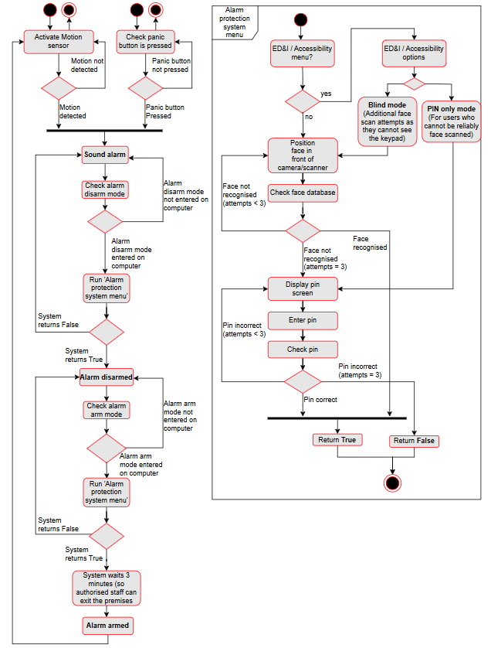

Sources/References

- PoiData.io Nov 2025 “How many Casinos are in United Kingdom?”
How many Casinos are in United Kingdom in 2025 (accessed 11 Nov 2025)

- Aylesbury fire systems 10 Feb 2025 “Understanding Intruder Alarm Legislation in the UK” https://aylesburyfire.co.uk/understanding-intruder-alarm-legislation-in-the-uk (accessed 8 Dec 2025)
- Marlowe fire and security “AUDIBLE & VISUAL ALARMS”https://marlowefireandsecurity.com/solutions/compliance/audible-visual-alarms/ (accessed 8 Dec 2025)

Smartdraw - used to design the floorplan (accessed 11 Nov 2025)

Chatgpt.com - used to design casino 404 logo (accessed 26 Nov 2025)

diagrams.net - used to design UML diagrams (accessed 26 Nov 2025)

